

MACAU UNIVERSITY OF SCIENCE AND TECHNOLOGY

School of Computer Science and Engineering
Faculty of Innovation Engineering

Senior Thesis for the Degree of Bachelor of Science

Title: Lunar Crater Recognition Accuracy Assurance via Ensemble Learning Techniques

Student Name : GongYiYuan
Student No. : 1210001880

Supervisor : YeBen

April, 2025

Abstract
This graduation project focuses on using machine learning algorithms for object detection to help accurately and automatically identify the locations of lunar craters. The YOLOv8 model was selected as the basis for improvement. Relevant improvements were made according to various characteristic points of lunar craters to improve the accuracy of the basic model in crater recognition.
For the problems in remote - sensing images, such as large differences in the sizes of lunar craters, blurred boundaries, and obvious differences in light and shadow features, iterative improvements were made one by one. This project used "The optical - DEM Paired Lunar Crater Detection (ODPLCD) dataset" publicly released by the National Space Science Data Center on October 30, 2022. This dataset provides 2784 pairs of lunar crater images.
The results of the data experiment include a comparison of YOLOv8, YOLOv5, Faster - CNN, and the improved YOLOv8. Each method was trained for 100 rounds.

Keywords: Lunar crater; YOLOv8; Attention mechanism; Object detection

Table of Contents
Abstract I
Table of Contents II
List of Figures IV
List of Tables V
Chapter 1 Introduction 1
1.1 Background and motivation 1
1.2 Thesis organization 3
Chapter 2 Related Theories and Technical Foundations 5
2.1 Object Detection Algorithm 5
2.1.1 Two-stage Object Detection Method 5
2.1.2 One-stage object detection algorithm 6
2.2 Dataset 10
2.3 Evaluation Metrics 10
Chapter 3 Technical Route 14
3.1 Research Process 14
Chapter 4 Optimization Directions 16
4.1 Optimize the detection head 16
4.2 Add the Convolution and Attention Fusion Module (CAFM). 17
4.3 Add the Omni - dimensional Dynamic Convolution (ODConv) module. 18
4.3.1 Overview of the ODConv Module 18
4.3.2 Four Attention Mechanisms of ODConv 18
4.3.3 Impact on Lunar Crater Detection 19
Chapter 5 Experimental Results 21
5.1 Comparison results 1 21
5.2 The experimental results of the improvement of YOLOv8 22
5.3 Experimental Results and Analysis 23
Chapter 6 Conclusion 27
6.1 Conclusion 27
6.2 Future work 27
References 29
Appendix 30
Resume 33
Acknowledgements 34

List of Figures
Figure 1-1 irregular lunar craters 2
Figure 1-2 Craters with obvious size differences 2
Figure 2-1 Structure Diagram of R-CNN 5
Figure 2-2 Faster R-CNN Network Model 5
Figure 2-3 Region Proposal Network（RPN） 5
Figure 2-4 YOLOv8 7
Figure 3-1 Technical Roadmap 14
Figure 4-1 Four groups of detection heads 16
Figure 4-2 CAFM 17
Figure 4-3 The attention mechanism of ODConv. 19
Figure 5-1 CAFM&ODConv 25
Figure 5-2 base YOLOv8 26

List of Tables
Table 1 YOLOv8, YOLOv5 and Faster-RCNN after 100 rounds of training 21
Table 2 Comparison of different improvements to YOLOv8 22
Table 3 Comparison of YOLOv8 with the added CAFM & ODConv modules under different numbers of training rounds 23

Introduction

Background and motivation
Lunar craters are key geological indicators for reconstructing the evolutionary history of the Moon. Traditional manual interpretation of lunar remote sensing images is very time-consuming and prone to subjective errors. Usually, geologists have to painstakingly study a large amount of data. At the same time, early machine learning techniques, such as those relying on Support Vector Machines (SVM) for feature extraction, have difficulty in handling complex terrain changes, which seriously affects the accuracy of crater recognition.

The emergence of deep learning has revolutionized the field of object detection, enabling end-to-end models to directly process raw images and output detection results. By consulting relevant materials, it is found that among the current deep learning-based object detection models, both YOLO (You Only Look Once) and DETR (End-to-End Object Detection with Transformers) have excellent performance. Based on the high expandability and low performance requirements of YOLO, this paper chooses to improve the YOLO method to enhance the recognition accuracy of lunar craters.

When applying the existing YOLO (You Only Look Once)-based models to the recognition of lunar craters, we still have to face some problems in lunar remote sensing images. Some target craters are too tiny. There are many areas on the lunar surface with low-contrast edges, where the boundaries between the craters and the surrounding terrain are not clearly defined. In addition, the long shadows cast by the irregular lunar terrain can cause feature ambiguity. The shadows may mimic the shape of craters or cover up the actual crater features, leading to classification errors of the YOLO-based detection algorithms.

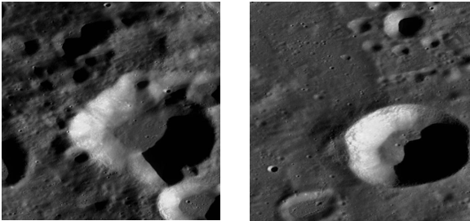
Figure 1-1 shows two types of craters with distinctly different outlines. After making a comparison, it can be found that compared with the second type of craters with more regular shapes, the first type of craters with irregular shapes are more difficult to identify. A single external feature cannot effectively identify such irregular craters. At the same time, we can also observe that craters with different outlines have crater boundaries of varying degrees of clarity, and the phenomenon of multiple craters overlapping occurs frequently.
Figure 1-1 irregular lunar craters
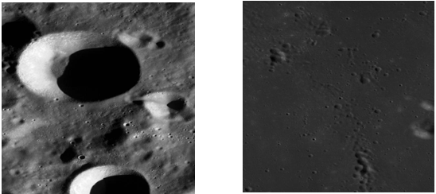
In Figure 1 - 2, we can clearly see that in different images, the proportion of small craters in the picture varies greatly compared with large craters. Tiny craters are not only small in size, but their boundaries are even more blurred. They are much harder to identify in photos with the same resolution.
Figure 1-2 Craters with obvious size differences

Based on the above - mentioned problems, the research motivations of this project are as follows:
(1) Since there is a large amount of data in manual identification of lunar craters, there may be dozens or even hundreds of craters in a single picture. Identifying lunar craters is a single - class object detection task. Therefore, this project uses the YOLOv8[1] object detection algorithm based on convolutional neural networks. Its detection speed is much faster than other traditional machine - learning algorithms. It has low performance requirements and strong generalization ability, which can adapt to detection tasks of different intensities.
(2) Since identifying lunar craters involves dealing with data provided by scientific research materials, ensuring accuracy is a very crucial indicator. After understanding the characteristics of lunar craters, this project aims to improve and optimize YOLOv8 to enhance the accuracy of lunar crater identification and increase the confidence rate of data output.

Thesis organization
Chapter 1: Introduction
This chapter introduces the background and motivation for lunar crater detection. It discusses the challenges of manual crater identification and highlights the significance of using deep learning algorithms, specifically the YOLOv8 model, for efficient and accurate lunar crater detection.
Chapter 2: Related Theories and Technical Foundations
In this chapter, we explore key concepts in object detection, with a focus on deep learning algorithms. It includes an overview of two-stage and one-stage object detection methods, particularly YOLO and Faster R-CNN. The chapter also discusses the dataset used in this research and the evaluation metrics employed to assess model performance.
Chapter 3: Technical Route
This chapter outlines the research process, including dataset preparation, model selection, and the evaluation of different object detection algorithms. It describes the methodology adopted for lunar crater detection and the decision-making process in selecting YOLOv8 as the base model for improvement.
Chapter 4: Optimization Directions
The chapter details the strategies used to optimize YOLOv8 for lunar crater detection. This includes enhancing the detection head, incorporating the Convolution and Attention Fusion Module (CAFM), and introducing the Omni-dimensional Dynamic Convolution (ODConv) module. These optimizations aim to improve the model’s ability to detect small objects and enhance its robustness in complex scenarios.
Chapter 5: Experimental Results
This chapter presents the experimental setup and results, comparing the performance of YOLOv8 with YOLOv5 and Faster-RCNN. It also evaluates the impact of the CAFM and ODConv modules on the model’s performance across different metrics such as precision, recall, and mAP.
Chapter 6: Conclusion
The final chapter summarizes the findings of this research, discusses the improvements made to YOLOv8, and outlines future work directions. It emphasizes the importance of these advancements in enhancing the accuracy and efficiency of lunar crater detection models.

Related Theories and Technical Foundations
This chapter provides an overview of the basic concepts and technical theories related to lunar crater detection, covering object detection algorithms, especially those using deep learning, and introduces the methods that form the basis of this study.

Object Detection Algorithm
In the current era of big data and information explosion, the development of computer hardware has significantly improved, and deep learning has been widely applied in multiple fields, especially in autonomous driving. Deep Convolutional Neural Networks (CNNs) offer significant advantages for autonomous driving. They can automatically extract high-level features from images, avoiding complex pre-processing steps. Compared with traditional image recognition methods, deep learning has made greater breakthroughs in both recognition effect and speed. The advantage of deep convolutional neural networks lies in their powerful feature recognition ability, which has rotational invariance and illumination invariance, and they can capture more object structure information.
Through the analysis of relevant research literatures at home and abroad, this paper summarizes two main types of object detection methods. The first type is the traditional two-stage object detection method. This method performs well in terms of accuracy, but due to the need for multiple steps, the detection speed is slow and it cannot meet the requirements of real-time detection. The second type is the one-stage object detection method. This method directly predicts the target category and object bounding box through a convolutional neural network, and only needs to conduct one detection to obtain the final result. Therefore, it has a faster detection speed and is especially suitable for application scenarios with high real-time requirements such as lunar crater detection, and it has received increasing attention from more and more researchers..

Two-stage Object Detection Method
The two-stage object detection method based on deep learning is one of the important algorithms in the field of object detection. This method mainly consists of two core parts. Firstly, a Convolutional Neural Network (CNN) is used as the backbone network to extract features from the candidate regions in the image. Then, the extracted feature information is transmitted to the Region Proposal Network to generate candidate regions.
Different from traditional object detection methods, the two-stage object detection method has the characteristic of end-to-end, which means that it does not require additional classifier training. Due to this characteristic, this method has significantly improved accuracy compared with traditional methods. However, the drawback of the two-stage method is its slow detection speed. This trade-off between speed and accuracy reflects that while pursuing higher accuracy, more complex computational tasks must be handled, especially in real-time application scenarios, where it may not be able to meet the real-time requirements.
R-CNN (Region-CNN) [2] combines region extraction and Convolutional Neural Network (CNN), transforming the object detection task into classification and localization problems. Its operation process can be divided into three main steps: selection of candidate regions, CNN feature extraction, and classification and annotation of targets.
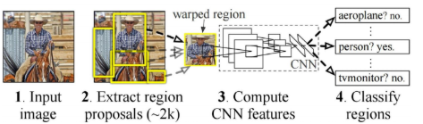
Firstly, the Selective Search algorithm is used to select 1,000 to 2,000 candidate regions on each image. This process can extract regions that may contain objects. Then, these candidate regions are input into the Convolutional Neural Network (CNN) for feature extraction, and the IoU (Intersection over Union) value between each candidate bounding box and the ground truth bounding box is calculated. When the IoU value is greater than 0.5, it is regarded as a positive sample. Subsequently, positive samples are classified through a Support Vector Machine (SVM), and the position of the candidate regions is corrected through bounding box regression (bbox regression). Finally, the object detection results are obtained.
Figure 2-1 Structure Diagram of R-CNN
R-CNN also has some drawbacks.
(1) A large number of candidate regions are generated, which takes up a lot of disk space.
(2) When the candidate regions are fed into the CNN, they need to be pre-normalized, which may lead to the loss of image information.
(3) Each candidate region needs to be input into the network separately for processing, resulting in the repeated extraction of the same features and thus wasting computing resources.
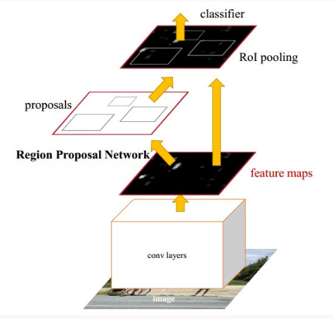
Faster R-CNN [3] is an effective improvement on the R-CNN and Fast R-CNN object detection algorithms. It further improves the speed and accuracy of object detection by introducing a Region Proposal Network (RPN). Compared with the traditional R-CNN series methods, Faster R-CNN significantly reduces the time for generating candidate regions and enables the network to be trained end-to-end.
Figure 2-2 Faster R-CNN Network Model
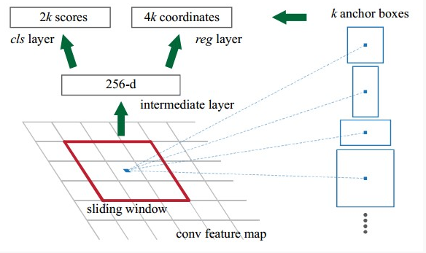
In Faster R-CNN, the input image is first subjected to feature extraction through a Convolutional Neural Network (CNN) to obtain the corresponding feature map. Then, a 3×3 convolutional layer is used to perform a sliding window operation. The window slides over the feature map, and each time it slides, multiple anchor boxes of different sizes and aspect ratios associated with the current window position are generated centered on this position. Usually, a combination of 3 different sizes and 3 aspect ratios is selected, with the value of k being 9. That is, 9 candidate boxes are generated at each position.
Figure 2-3 Region Proposal Network（RPN）
The anchor boxes are then passed through two parallel 1×1 convolutional layers, which respectively output the scores of the targets and four regression parameters. These parameters are used to adjust the positions and sizes of the anchor boxes, thus generating the final region proposals. Through this method, the RPN is able to automatically generate high-quality region proposals and share convolutional features with the classification network for object detection, enabling more efficient object detection.

One-stage object detection algorithm
One-stage object detection algorithm is a relatively simple and efficient object detection method. Different from traditional two-stage object detection algorithms, one-stage algorithms do not need to generate candidate regions first. Instead, they directly perform localization and classification on the input image, transforming the object detection problem into a regression problem. This approach greatly simplifies the detection process and significantly improves the detection speed.
The core advantage of one-stage detection algorithms lies in their high efficiency. Since there is no need for the candidate region generation process, one-stage algorithms can complete object detection tasks in a relatively short time, making them particularly suitable for practical application scenarios that require rapid processing. Common one-stage object detection algorithms include YOLO, SSD, and RetinaNet. Among them, the YOLO series is widely used in real-time object detection tasks.
A notable feature of the YOLO series of algorithms is that they transform object detection into a regression problem. This algorithm divides the image into multiple grids, and each grid is responsible for predicting the object's category and bounding box position.
In general, one-stage object detection algorithms improve detection efficiency by simplifying the processing flow. Without sacrificing accuracy, they can meet the speed requirements and are an important method in modern object detection tasks.
The algorithm adopted in this project is the YOLOv8 algorithm. YOLOv8 is a series of improvements and optimizations made by Ultralytics on the basis of the YOLOv5 algorithm, aiming to enhance the model's performance, speed, and accuracy, especially achieving a significant improvement in accuracy.
The network architecture of YOLOv8 mainly consists of four key parts: the Input layer at the input end, the Backbone layer as the network backbone module, the Neck layer as the feature enhancement module, and the Head layer at the output end. The structure of its network model is shown in Figure 2 - 4. In this architecture, the Input layer is responsible for feeding the image to be detected into the Backbone layer; the Backbone layer performs feature extraction on the image; the extracted features are subjected to pooling and feature fusion processing through the Neck layer; and finally, the Head layer outputs the detection results.
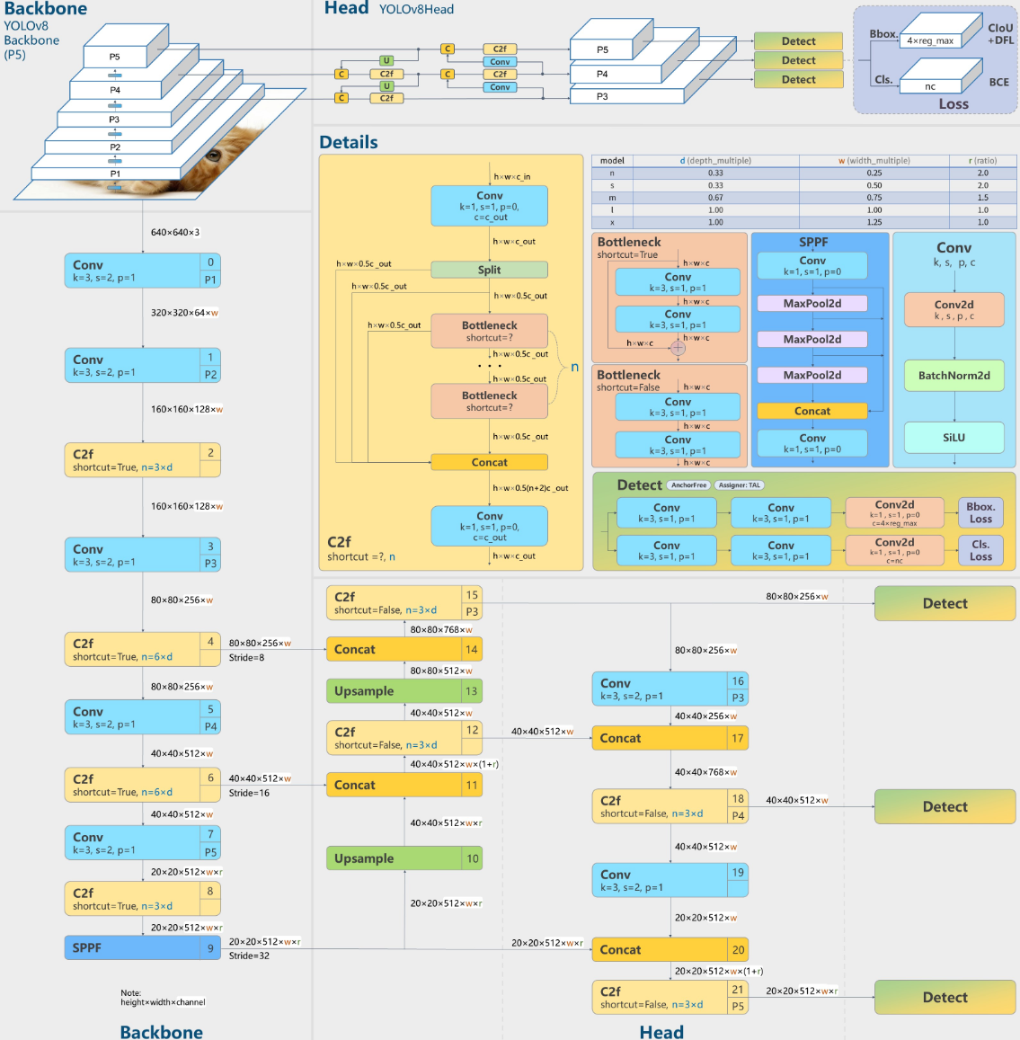
Figure 2-4 YOLOv8
Input Layer
The Input layer is the initial layer where the model receives the input image. It is responsible for receiving the raw image data, converting it into a format that the model can process, and feeding it into the model as the initial input data.
The Input layer of the YOLOv8 algorithm inherits the data augmentation strategies from YOLOv5, such as Mosaic augmentation, Mixup augmentation, and random perspective.
Backbone Layer
The Backbone network of this algorithm mainly consists of the SPPF module, the CBS module, and the C2f module. Among them, the SPPF module effectively fuses features of different scales through fast spatial pyramid pooling operations, enhancing the model's adaptability to changes in target scales; the CBS module integrates convolution (Conv), batch normalization (BatchNorm), and activation function (SiLU) operations to achieve efficient feature extraction and normalization; the C2f module is based on the idea of cross - stage partial connection. Through specific convolutions and skip connections, it optimizes gradient propagation and improves the network's ability to extract image features.
Neck Layer
The Neck part of YOLOv8 uses the FPN + PAN structure to build a feature pyramid, aiming to strengthen the fusion of multi - scale information. FPN (Feature Pyramid Network) and PAN (Path Aggregation Network) combine features of different scales to improve the detection ability for objects of different sizes. Compared with the FPN - PAN structure of YOLOv5, YOLOv8 optimizes the C3 module into the C2f module. With a richer gradient flow, the C2f module can capture image details more effectively. Especially in the detection of small objects, it can achieve more efficient information transfer and improve the detection performance.
Head Layer
The Head part of YOLOv8 has significant improvements compared with YOLOv5, mainly in the following two aspects:
1) Decoupled Head Structure
From YOLOv3 to YOLOv5, the object detection head has always adopted a Coupled Head structure. It was not until 2021 when Zheng Ge et al. proposed YOLOX that the Decoupled Head structure was introduced into the YOLO series for the first time. YOLOv8 continues this design. The Decoupled Head separates the classification task from the regression task, using independent branches to extract category features and position features respectively, and each branch is implemented through a 1×1 convolutional layer. Experiments show that the Decoupled Head not only speeds up the convergence but also improves the detection accuracy, outperforming the Coupled Head structure in the same detection task.
2) Anchor Free Concept
YOLOv8 introduces the Anchor Free concept on the basis of traditional one - stage and two - stage detection algorithms, avoiding the drawbacks of the traditional anchor box method. Although traditional anchor boxes can improve the detection accuracy of similar objects, they have many problems: anchor boxes need to be manually designed, which is complex and difficult to adapt to objects of different sizes; a large number of anchor boxes are generated during detection, increasing the computational time and causing an imbalance between positive and negative samples; the adjustment of a large number of hyperparameters affects the training efficiency and the stability of the results. YOLOv8 uses the Anchor Free method to directly predict the target position and category, effectively solving the above problems and improving the detection efficiency and accuracy.
Varifocal Loss Classification Loss Function
The loss function of YOLOv8 mainly includes a classification loss function and a regression loss function, which are Varifocal Loss and CIOU Loss + DFL respectively.
1) Classification Loss Function
The classification loss function is used to evaluate the accuracy of the model in classifying target types. YOLOv8 uses an improved cross - entropy loss function, Varifocal Loss, to calculate the classification loss. This function integrates the idea of traditional cross - entropy loss and focuses on the regional focus of different targets during the classification process, improving the model's classification accuracy in complex scenarios. By adjusting the target focus area, it strengthens the attention to difficult - to - classify objects, making up for the deficiencies of ordinary cross - entropy in a multi - category and complex object environment.
2) Regression Loss Function
The regression loss function is used to measure the accuracy of the model's prediction of the target position. YOLOv8 uses CIOU Loss and DFL (Distribute Focused Loss) to optimize the regression task. The combination of the two makes YOLOv8 more accurate in object positioning and helps the bounding box better fit the target object.
Summary
Through improvements to the Neck and Head parts, the introduction of the Anchor Free method, and the optimization of the loss function, YOLOv8 performs excellently in terms of accuracy, speed, and the ability to detect small objects. When dealing with complex backgrounds and multi - scale object detection tasks, these improvements make it more adaptable and efficient in practical applications. Compared with YOLOv5, YOLOv8 has significant advantages in multiple aspects such as network structure, data processing, feature extraction, object detection, and loss calculation. In tasks such as lunar crater detection, which require high precision and involve complex target scales, YOLOv8 can provide a fast and accurate object detection solution.

Dataset
The training dataset used in this study is the ODPLCD [4] Optical-DEM Paired Lunar Crater Detection Dataset. The dataset contains 2,784 pairs of lunar crater sample images, among which 1,781 pairs are used for the training set, 446 pairs for the validation set, and 557 pairs for the test set.
The optical images (near-infrared band) in ODPLCD were collected by the Wide Angle Camera (WAC) of the Lunar Reconnaissance Orbiter Camera (LROC) carried by the Lunar Reconnaissance Orbiter (LRO). With a resolution of 100 meters per pixel (m), these images cover the area from 90° south latitude to 90° north latitude and from 180° west longitude to 180° east longitude. The DEM (Digital Elevation Model) images were collected by the Lunar Orbiter Laser Altimeter (LOLA) carried by both the LRO and the Kaguya satellite, with a resolution of 59 meters per pixel..

Evaluation Metrics
In the evaluation of YOLOv object detection, common evaluation metrics include Precision, Recall, mAP50 (mean Average Precision at an IoU threshold of 0.5), mAP50 - 95 (mean Average Precision at IoU thresholds ranging from 0.5 to 0.95), and Box metrics. The following is a corresponding introduction to them:
During the evaluation process of the YOLOv8 object detection model, common evaluation metrics include Precision, Recall, mAP50 (mean Average Precision at an IoU threshold of 0.5), mAP50 - 95 (mean Average Precision at IoU thresholds ranging from 0.5 to 0.95), and Box metrics. The following is a detailed introduction to these evaluation metrics and their formulas.
Precision (Accuracy)
Precision indicates the proportion of actual positive samples among all the images that the model has predicted as positive samples. It measures how many of the positive samples predicted by the model are genuine targets.
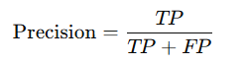
Formula:

Among them:
• TP (True Positives) represents true positives, which indicates the number of samples that the model correctly predicts as positive samples.
• FP (False Positives) represents false positives, which indicates the number of samples that the model incorrectly predicts as positive samples.
Recall (Sensitivity)
Recall represents the proportion of positive samples that the model can correctly detect among all the actual positive samples. It measures the model's ability to recall positive samples and focuses on the coverage of the targets.
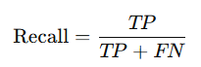
Formula:
Among them:
• FN (False Negatives) represents false negatives, which indicates the number of actual targets that are missed by the model.

mAP50 (mean Average Precision at IoU threshold 0.5)
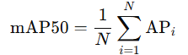
mAP50 is a commonly used metric for evaluating the accuracy of object detection models. It represents the model's mean Average Precision (AP) when the Intersection over Union (IoU) threshold is set to 0.5. The calculation method is to first compute the AP for each class and then find the average value across all classes.
Formula:
Among them, N is the number of categories, and APi is the average precision of the i-th category.
The calculation of AP is based on the area under the Precision-Recall curve. Different IoU (Intersection over Union) thresholds (such as 0.5) are often used to evaluate the performance of the model.
mAP50-95 (mean Average Precision at IoU thresholds from 0.5 to 0.95)
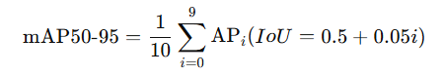
mAP50-95 is a more stringent evaluation criterion. It calculates the Average Precision (AP) at multiple different values of the IoU (Intersection over Union) threshold ranging from 0.5 to 0.95 (usually with a step size of 0.05), and then computes the average of these APs.
Formula:

Among them, APi represents each AP value when the IoU (Intersection over Union) threshold ranges from 0.5 to 0.95.
Box (Bounding Box Metric)
The Box metric measures the degree of overlap between the predicted bounding box and the ground truth bounding box, which is usually calculated by means of IoU (Intersection over Union). IoU represents the ratio of the intersection area of the predicted box and the ground truth box to their union area. The higher the IoU value is, the better the overlap between the detection box and the ground truth box.
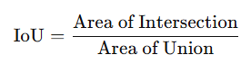
Formula:
Among them, the IoU value usually depends on a specific threshold (such as 0.5) and is used to determine whether the predicted box is a positive example.
In the evaluation of YOLOv8, through metrics such as Precision, Recall, mAP50, mAP50-95, and Box, the detection performance of the model can be comprehensively evaluated. These metrics can not only help measure the accuracy and recall ability of the model, but also assess the performance of the model under different IoU thresholds, thus better guiding the model optimization. For lunar craters, the targets often have small sizes, irregular shapes, and complex backgrounds. Therefore, Precision is particularly important for the evaluation of the lunar crater recognition model. It measures the proportion of the areas actually being lunar craters among all the areas predicted as craters by the model. In complex lunar images, it is crucial to avoid false detections. Therefore, high precision can ensure that the model minimizes the occurrence of false detections during prediction.

Technical Route
This research focuses on the identification of lunar craters and follows the following route.

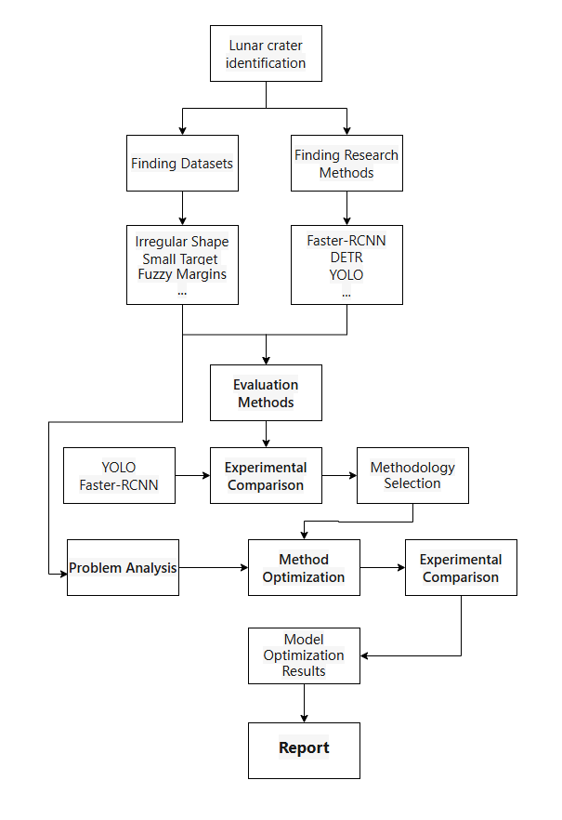
Research Process
Figure 3-1 Technical Roadmap
Preliminary Preparation: First, carry out the work of finding the dataset and exploring the research methods. On the one hand, look for a suitable dataset to lay a data foundation for subsequent experiments. On the other hand, conduct research on various object detection research methods such as Faster-RCNN, DETR, and YOLO, analyze their principles and applicable scenarios, and reserve technical solutions for the research on lunar crater identification.
• Evaluation and Preliminary Experiments: Determine the evaluation method suitable for the task of lunar crater identification according to the characteristics of lunar craters, such as irregular shapes, small targets, and blurred edges. Based on this, apply methods like YOLO and Faster-RCNN to the obtained dataset for training and experimental comparison. By comparing the performance of different methods in the task of crater identification, evaluate the advantages and disadvantages of each method, and select a suitable basic research method from them.
• Method Optimization and Verification: Conduct in-depth problem analysis of the selected basic method. According to the characteristics of lunar craters and the difficulties in detection, optimize the method in a targeted manner. After the optimization, carry out experimental comparisons again to test the optimization effect. Through continuous adjustment of the optimization strategy, achieve the gradual improvement and perfection of the method and obtain the model optimization results.
• Result Presentation: Based on a series of experimental and optimization achievements, write a research report to comprehensively expound the research process of lunar crater identification, the content of method optimization, experimental results, and the final conclusion.

Optimization Directions

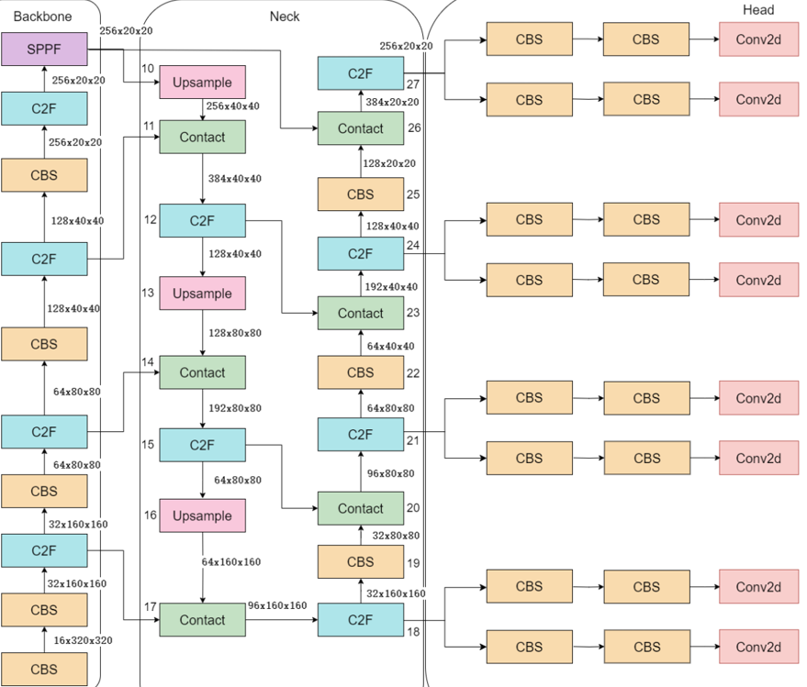
Optimize the detection head
Figure 4-1 Four groups of detection heads

Due to the characteristic of size differences of lunar craters, the multi-scale detection head is of great significance in this object detection model. The basic YOLOv8 model has three detection heads, which are used to handle targets of different scales: large (with a size of 256), medium (with a size of 128), and small (with a size of 64). However, for extremely small lunar crater targets, these three scales may still not be sufficient to effectively capture them. Therefore, we consider adding a more refined detection head (with a size of 32) specifically for dealing with these small targets. By adding a refined small-target detection head (size = 32) to the Head part of YOLOv8, it affects the processing method of the model in detecting targets of different scales. The Head part of YOLOv8 is responsible for generating the final object detection results, including the prediction of the object category and the regression of the bounding box. After adding the small-target detection head, the feature fusion strategy of the Neck part needs to process the additional features from the detection head of the 32px scale. This modification enables the Neck part to effectively process the features from different scales, especially the features of small targets, thus improving the overall accuracy and stability of detection.

Add the Convolution and Attention Fusion Module (CAFM).
The original paper of CAFM[5] (Convolution and Attention Fusion Module) proposed a model called Hybrid Convolutional and Attention Network (HCANet).
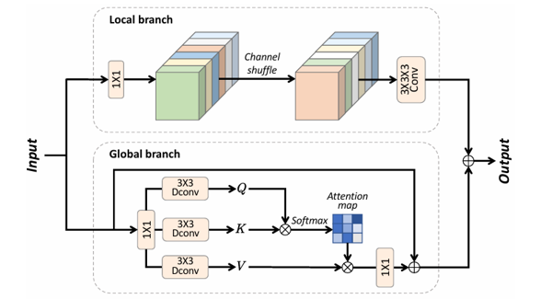
To improve the detection ability for small targets and occluded situations in lunar crater recognition, I introduced CAFM into the YOLOv8 model. This network combines the advantages of Convolutional Neural Networks (CNNs) and Transformer models, enhancing the feature extraction effect through local feature capture and global feature modeling.
Figure 4-2 CAFM
The CAFM module consists of two main branches: the local branch and the global branch. The local branch uses convolution operations for feature extraction, focusing on capturing the local details of the image. The global branch, on the other hand, uses the attention mechanism to model the global feature dependencies, thereby enhancing the understanding of global information.
We mainly focus on the local branch, which employs convolution operations and channel shuffle to effectively capture local feature information. Convolution can well capture the local details in the image, such as the features of small craters.
For small targets like lunar craters, traditional convolutional neural networks may have insufficient detection accuracy, especially in complex backgrounds caused by lighting or when multiple crater targets overlap and occlude each other. By combining the advantages of convolution operations and the attention mechanism, the CAFM module can effectively improve the model's performance in this task.

Add the Omni - dimensional Dynamic Convolution (ODConv) module.
To enhance the object detection ability in lunar crater recognition, especially when dealing with small targets in complex scenarios, I introduced the Omni - dimensional Dynamic Convolution (ODConv) module [6] into the YOLOv8 model. ODConv is a new type of Convolutional Neural Network (CNN) architecture. It dynamically adjusts the shape and size of the convolution kernel to adapt to different input data dimensions, thereby improving the model's flexibility and performance.

Overview of the ODConv Module
The ODConv optimizes the convolution operation by applying different types of attention mechanisms in the four dimensions of the convolution kernel space. It introduces different attention mechanisms in the spatial dimension, input channel dimension, output channel dimension, and convolution kernel dimension, allowing the convolution kernel to make adaptive adjustments across multiple dimensions. Its unique design of adaptive adjustment enables the ODConv to well meet the detection requirements for lunar craters, which are in complex lighting backgrounds and have multi - scale targets.

Four Attention Mechanisms of ODConv
As shown in Figure 4 - 3, ODConv decomposes the convolution operation into four different attention mechanisms:
• Location - wise attention: Adjusts the convolution kernel in the spatial dimension, making it pay more attention to specific positions in the image.
• Channel - wise attention: Applies the attention mechanism in the input channel dimension to adjust the responses of the convolution kernel in different channels.
• Filter - wise attention: Adjusts the convolution kernel in the output channel dimension so that it can better capture different features.
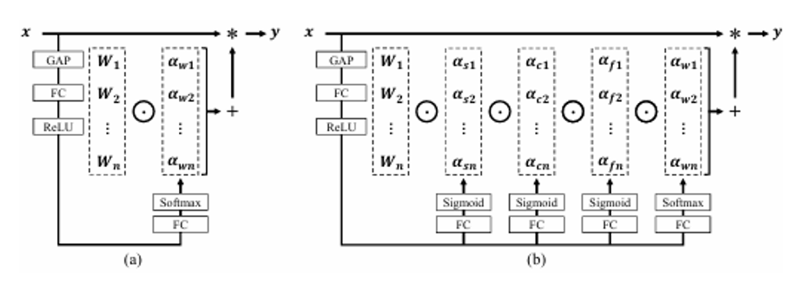
• Kernel - wise attention: Applies the attention mechanism in the dimension of the convolution kernel. By dynamically adjusting the shape and size of the convolution kernel, it improves the ability to perceive different features.
Figure 4-3 The attention mechanism of ODConv.

Impact on Lunar Crater Detection
In the lunar crater recognition task, the target craters are often small, which makes it difficult for traditional convolution operations to effectively capture these small targets, especially against complex backgrounds. Additionally, there may be craters of different sizes that interfere with the target craters in the lunar environment, further increasing the difficulty of target detection. ODConv, with its ability to dynamically adjust the convolution kernel, can provide better support for multi - scale feature extraction, thereby improving the model's performance in lunar crater detection.
The introduction of the ODConv module has had a positive impact on lunar crater detection in the following aspects:
- Improving the detection accuracy of small targets: Lunar craters are usually small and irregular in shape. ODConv can dynamically adjust the convolution kernel, enabling the network to better capture the detailed features of these small targets and enhancing the detection ability for small targets.
- Enhancing the recognition ability for interfered targets: In lunar images, craters may be partially occluded due to environmental factors (such as changes in lighting and terrain undulations) or affected by sub - craters. ODConv, through its multi - dimensional attention mechanism, can enhance the network's understanding of local and global information, thus improving the detection accuracy under occlusion and other interference conditions.

Experimental Results
Display and summarize the experimental results of the project.

Comparison results 1
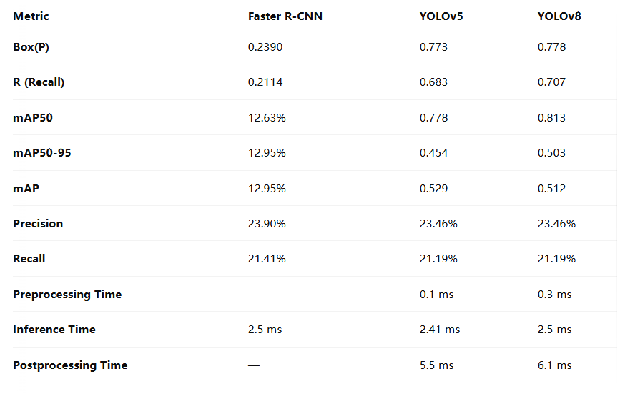
The comparison results of YOLOv8, YOLOv5 and Faster-RCNN after 100 rounds of training, using the same dataset.
Table 1 YOLOv8, YOLOv5 and Faster-RCNN after 100 rounds of training
YOLOv8 proves to be the most robust and efficient model, especially in terms of accuracy, precision, and recall. It is suitable for real-time detection tasks, including lunar crater detection, as it maintains a good balance between speed and accuracy.
YOLOv5 is a strong contender for real-time detection tasks but with slightly lower recall and precision than YOLOv8.
Faster R-CNN offers falls short in recall and mAP, making it less suitable for tasks requiring fast and reliable detection, especially when small objects or occlusions are involved.

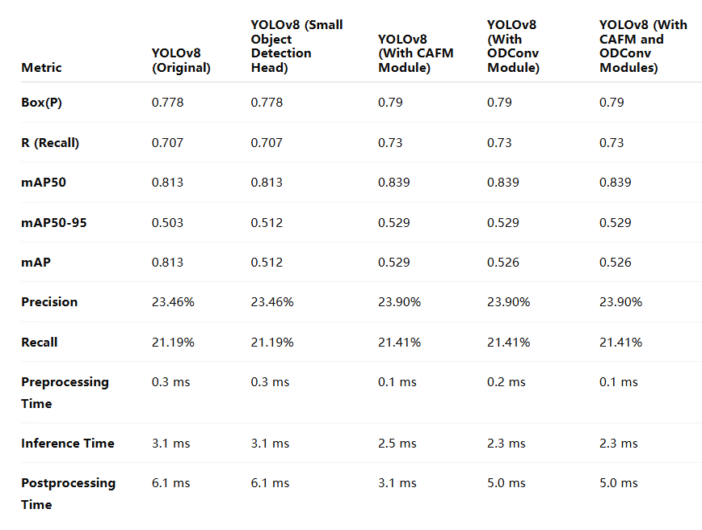
The experimental results of the improvement of YOLOv8
Table 2 Comparison of different improvements to YOLOv8
By incorporating both the CAFM module and the ODConv module, YOLOv8 shows improved performance in lunar crater detection, particularly for small object detection and in complex background scenarios. These two modules enhance the model’s multi-scale feature extraction ability and increase robustness in detecting occluded targets. At the same time, inference speed and processing efficiency are well-maintained, making the model more efficient for real-world applications.
The experimental comparison conducted over 100 rounds has proven that the improvement approach, namely the addition of the CAFM and ODConv modules, is effective. We will continue to increase the number of training rounds to explore the ultimate performance of this model.

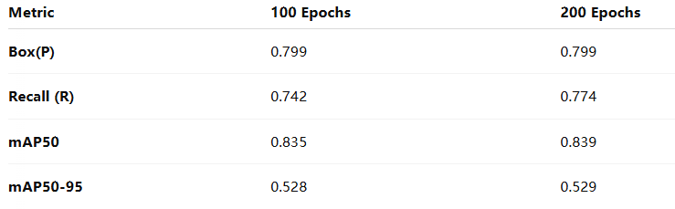
Box(P): During the 100 - round and 200 - round training, the precision of the predicted bounding boxes remained unchanged at 0.799. This indicates that the increase in the number of training rounds did not significantly affect the model's accuracy in target localization.
Table 3 Comparison of YOLOv8 with the added CAFM & ODConv modules under different numbers of training rounds
Recall: As the number of training rounds increased, the recall rate improved from 0.742 to 0.774. This shows that the model can better detect targets with more training.
mAP50: The increase in the number of training rounds slightly improved the mAP50 from 0.835 to 0.839, suggesting that the model's performance at medium - level precision has been enhanced.
mAP50 - 95: There was little change in this metric, indicating limited improvement in high - precision object detection.
Increasing the number of training rounds mainly improved the recall rate and the detection performance at medium - level precision. However, it had limited impact on improving the target localization accuracy (Box(P)) and the high - precision detection performance.

Experimental Results and Analysis
1. Training Loss
- train/box_loss: In the CAFM & ODConv model, the train/box_loss (training bounding - box loss) decreased rapidly and stabilized at an earlier stage. This indicates that the model can learn and converge quickly within a relatively short training time. In the base YOLOv8 model, the loss decreased at a slightly slower pace but eventually stabilized. This implies that the CAFM & ODConv modules can more effectively reduce the loss during training and improve the training efficiency.
- train/cls_loss: The classification loss in the CAFM & ODConv model showed a stable downward trend and entered the stable phase earlier. In contrast, the decrease in the base YOLOv8 model was relatively small. This indicates that after adding the modules, the model can optimize its classification ability more quickly during training.
- train/dfl_loss: In the CAFM & ODConv model, the train/dfl_loss (training distribution focal loss) also decreased rapidly in the initial stage, suggesting that the modules can quickly improve the model's ability to make detailed predictions. The base YOLOv8 model showed a slow - decreasing trend over a longer period.
2. Validation Loss
- val/box_loss: The validation bounding - box loss of the CAFM & ODConv model gradually decreased and stabilized over multiple epochs, which validates the stronger generalization ability of this model on different datasets. In comparison, the validation bounding - box loss of the base YOLOv8 model decreased more slowly, indicating its poorer performance on the validation dataset.
- val/cls_loss: The classification loss of the CAFM & ODConv model on the validation dataset decreased significantly, which shows that the modules improved the model's ability to recognize target classes. The base YOLOv8 model showed a slower improvement process.
- val/dfl_loss: The CAFM & ODConv modules helped the dfl_loss in the validation phase to decrease more significantly, enhancing the model's ability to accurately predict the target positions.
3. Evaluation Metrics
- Precision: In the metrics/precision graph, the precision of the CAFM & ODConv model gradually increased and remained stable in the later stage of training. This indicates that the model with the added modules can effectively reduce false alarms. The increase in the precision of the base YOLOv8 was relatively small, meaning that its precision is lower for small targets or in complex scenarios.
- Recall: The metrics/recall graph shows that the recall of the CAFM & ODConv model increased steadily during training, indicating that this model can better detect unrecognized targets. The improvement in the recall of the base YOLOv8 model was relatively slow, suggesting that this model may miss some small and difficult - to - detect targets.
- mAP50: The metrics/mAP50 graph shows that the mean average precision (mAP50) of the CAFM & ODConv model at an IoU threshold of 0.5 was significantly better than that of the base YOLOv8 model. This indicates that the addition of the CAFM & ODConv modules improved the model's accuracy in target localization and classification.
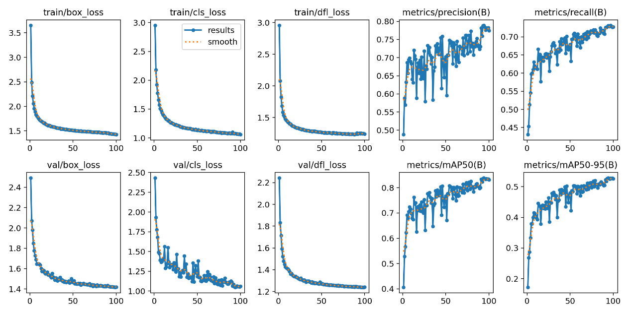
- mAP50 - 95: The CAFM & ODConv model also showed better performance in the mAP50 - 95 metric. Especially in the detection of multi - scale and small targets, the model can steadily improve the detection accuracy, which proves the adaptability of these modules to targets of different scales and difficulties.
Figure 5-1 CAFM&ODConv
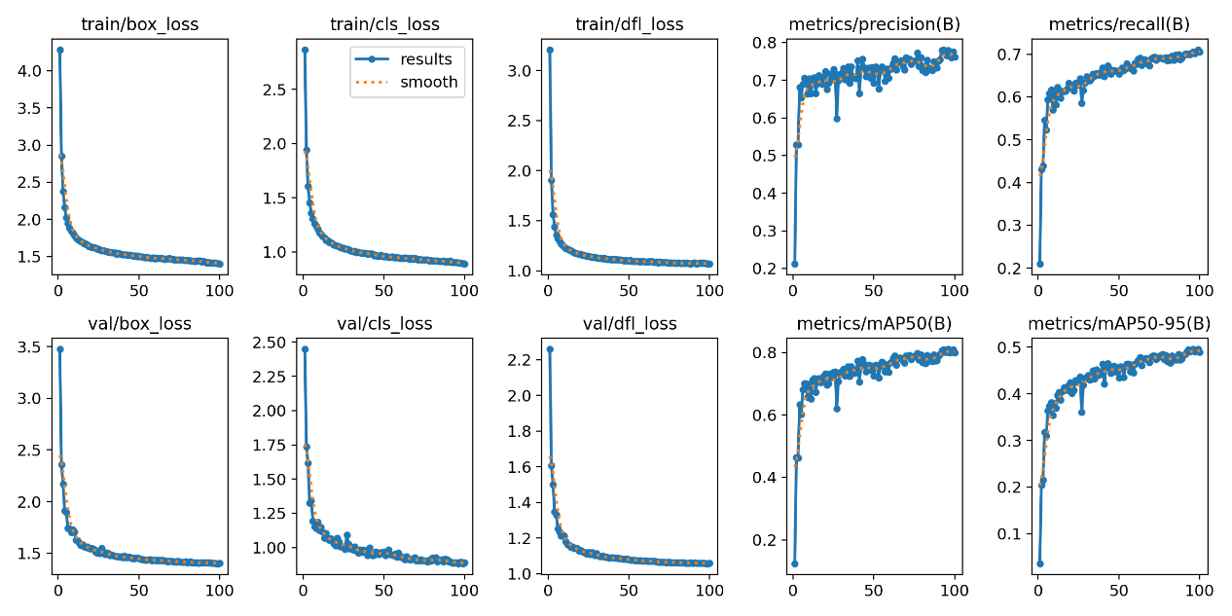
Figure 5-2 base YOLOv8

Conclusion

Conclusion
During the training optimization process, by adding a small object detection head branch, the CAFM module (Convolution and Attention Fusion Module), and the ODConv module (Omni-dimensional Dynamic Convolution), these improvements have effectively enhanced the model's ability to recognize small objects and its adaptability to complex scenarios (such as occlusion or a complex background).
Judging from the experimental results, through these optimizations, the model has not only improved the recall rate and detection accuracy but also effectively reduced the phenomenon of missed detections. Especially in the task of detecting lunar craters, which are small objects, the accuracy has been further enhanced.
Ultimately, the YOLOv8 model with the addition of the CAFM and ODConv modules has achieved a relatively high accuracy and a good recall rate in the task of lunar crater detection. Particularly, after a series of improvements, it can more effectively identify small objects and objects in complex backgrounds. Although there is still room for optimization under higher accuracy requirements, the performance of this model is sufficient to address most of the challenges in practical applications.

Future work
In the current model, YOLOv8 has already brought about a significant improvement in accuracy compared to YOLOv5. However, with the continuous release of new versions, the subsequent YOLOv11 or even higher versions may offer greater advantages in terms of accuracy, speed, and processing capabilities. Future work will involve exploring the replacement of YOLOv8 with YOLOv11. By leveraging the technological innovations of the new version, we aim to further enhance the object detection accuracy.
Introduction of More Advanced Model Architectures
DETR (DEtection TRansformer): DETR is an end-to-end object detection model based on the Transformer architecture. In recent years, it has achieved remarkable results in many object detection tasks. DETR utilizes the self-attention mechanism to model global context information, which gives it certain advantages in handling complex scenarios and detecting small objects. In future work, we will attempt to combine DETR with YOLO, or use the DETR model independently, and explore its application in lunar crater detection, so as to further improve accuracy and robustness.
Optimization of the Detector's Multi-scale Capabilities
Further Enhancement of Small Object and Occlusion Detection Abilities: Although the current model has achieved good results in detecting large objects, there is still room for improvement in handling small objects, partial occlusions, and complex backgrounds. In the future, we can further optimize the small object detection head to enhance the detection ability for objects of different scales. At the same time, by combining the self-attention mechanism with local feature extraction, we can improve the detection performance of the model in occlusion scenarios.

References
- Terven J ,Esparza C M D ,González R A J .A Comprehensive Review of YO LO Architectures in Computer Vision: From YOLOv1 to YOLOv8 and YOLO -NAS[J].Machine Learning and Knowledge Extraction,2023,5(4):1680-1716..
- Girshick R, Donahue J, Darrell T, et al. Rich feature hierarchies for accurate object detection and semantic segmentation[C]. Proceedings of the IEEE conference on computer vision and pattern recognition. 2014: 580-587.
- P Ren S, He K, Girshick R, et al. Faster R-CNN: Towards real-time object detection with region proposal networks[J]. IEEE transactions on pattern analysis and machine intel-ligence, 2016, 39(6): 1137-1149
- Yuqi Dai. ODPLCD[DS/OL]. V1. Science Data Bank, 2022[2025-04-28]. https://doi.org/10.57760/sciencedb.o00009.00312. DOI:10.57760/sciencedb.o00009.00312.
- S. Hu, F. Gao, X. Zhou, J. Dong and Q. Du, "Hybrid Convolutional and Attention Network for Hyperspectral Image Denoising," in IEEE Geoscience and Remote Sensing Letters, vol. 21, pp. 1-5, 2024, Art no. 5504005, doi:10.1109/LGRS.2024.3370299.
- Li, Chao, Aojun Zhou, and Anbang Yao. "Omni-dimensional dynamic convolution." arXiv preprint arXiv:2209.07947 (2022).

Appendix
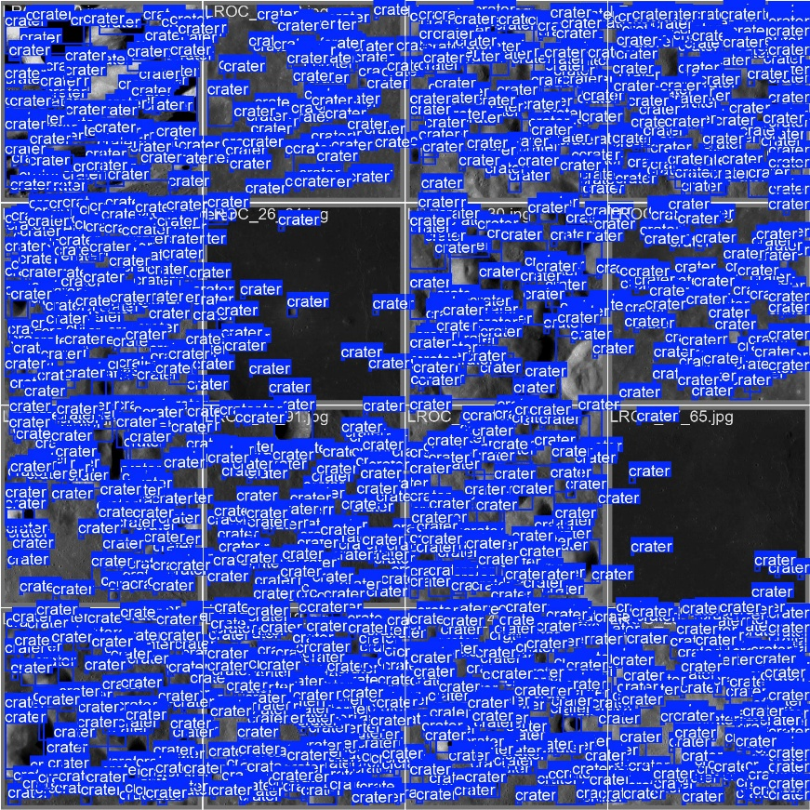
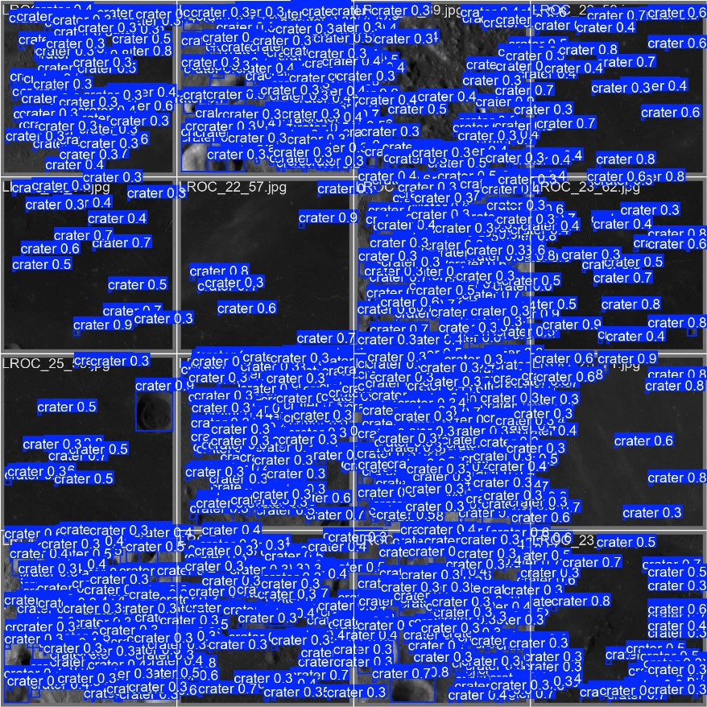
Model Performance Demonstration：

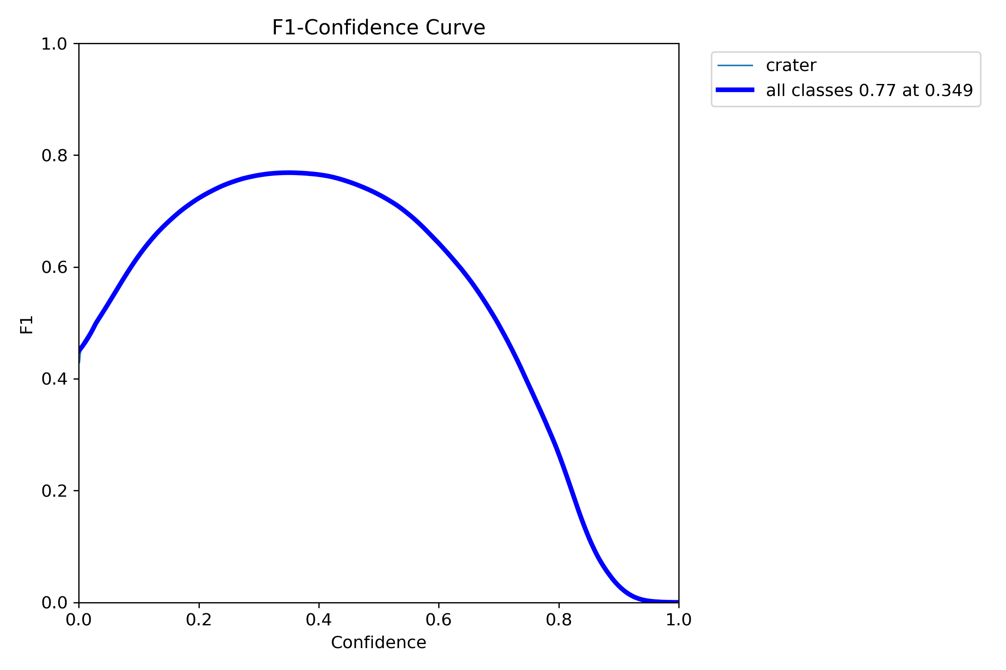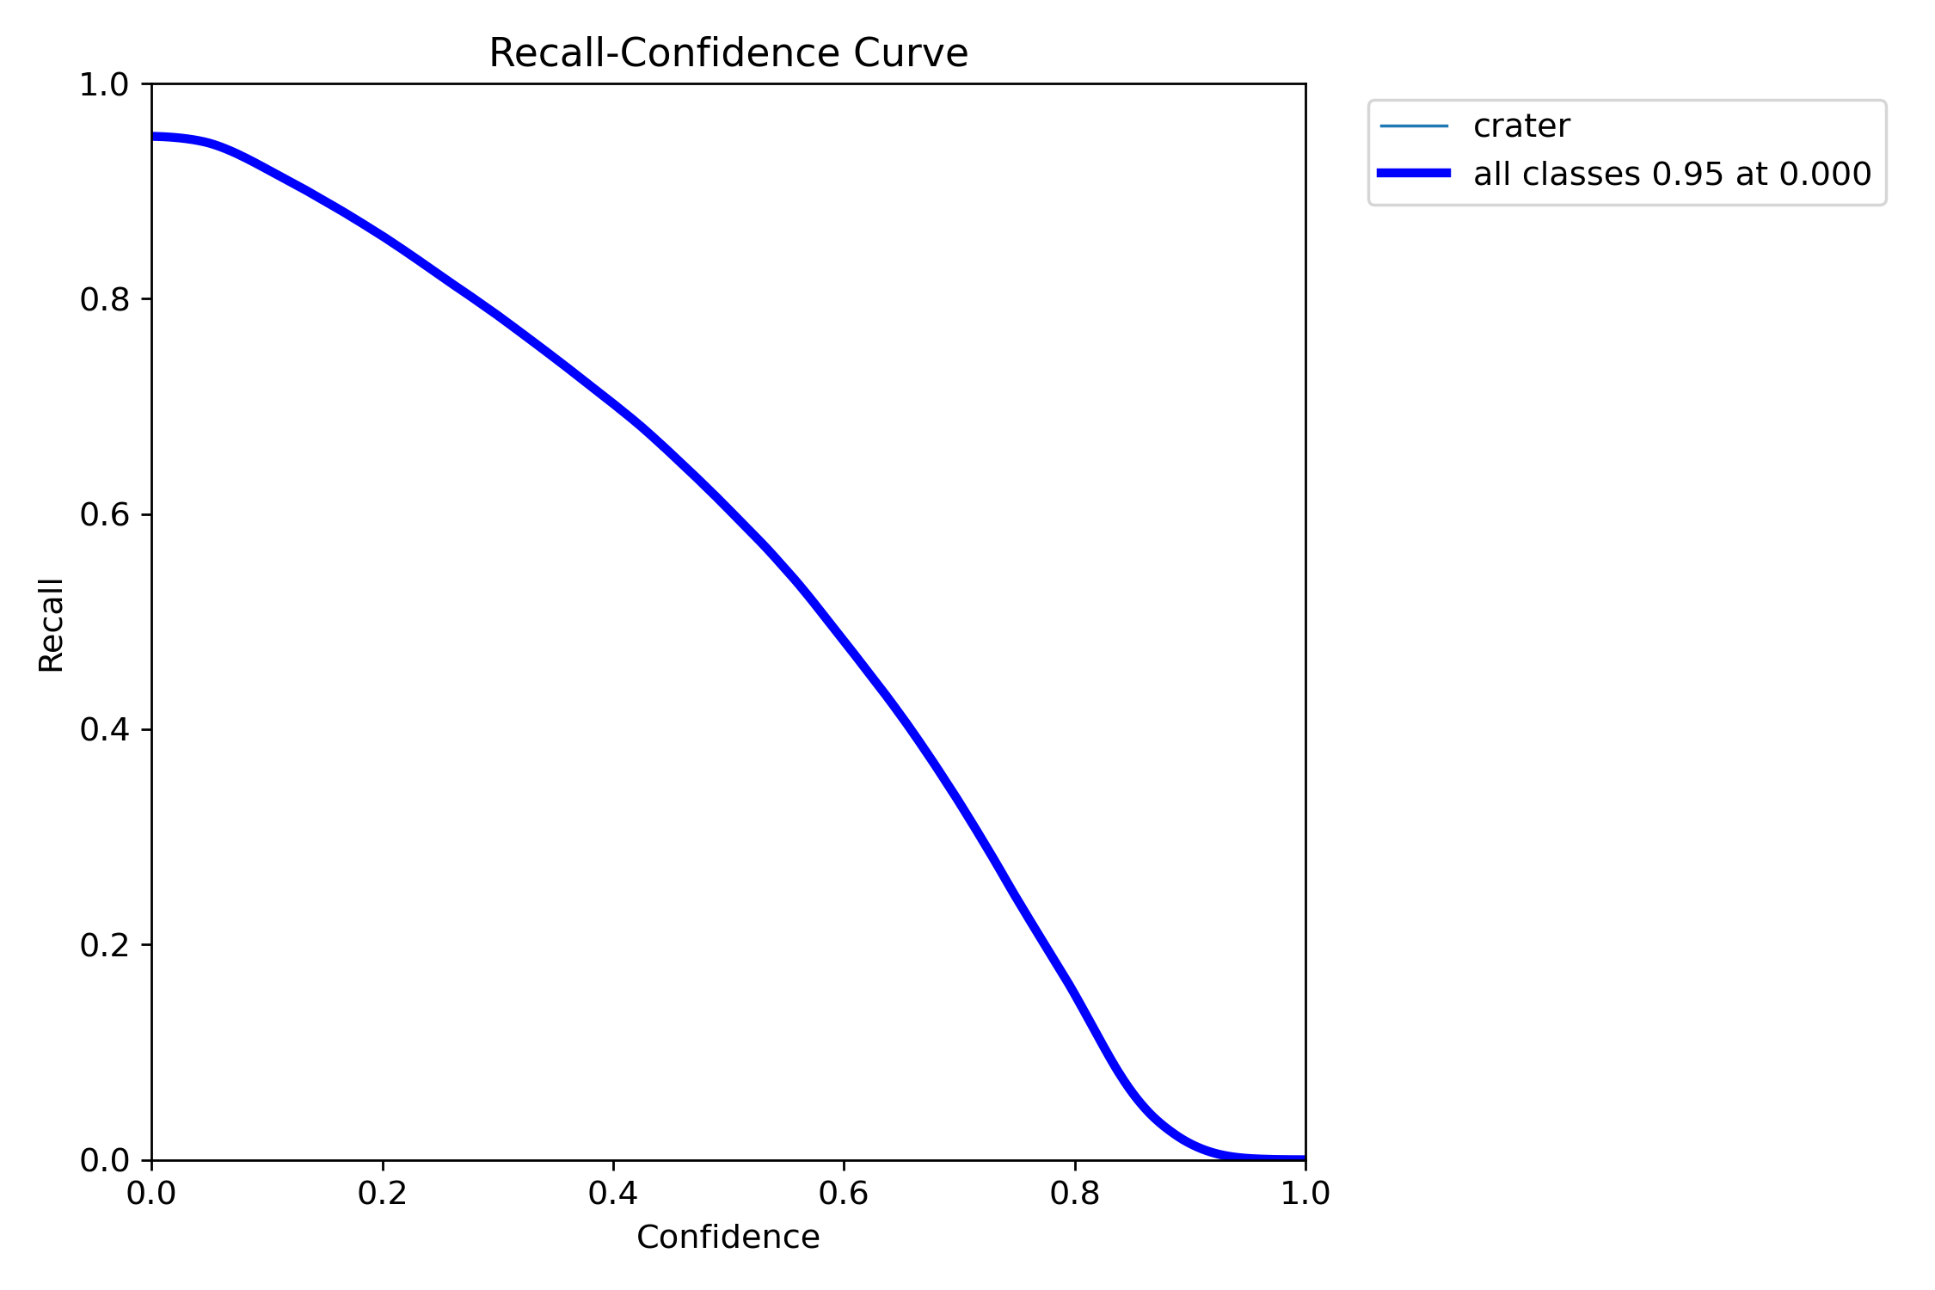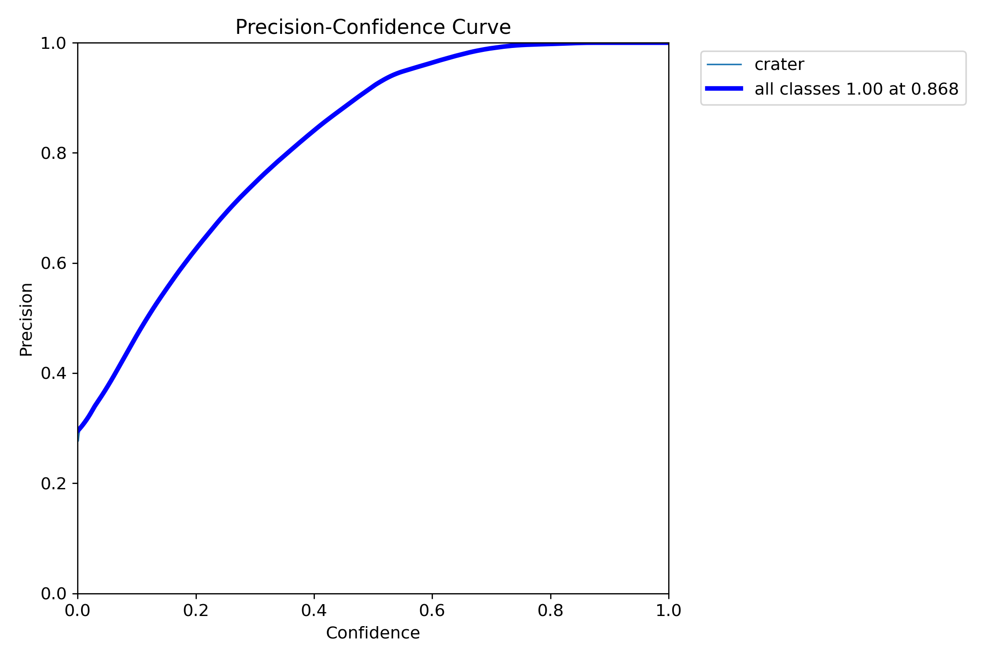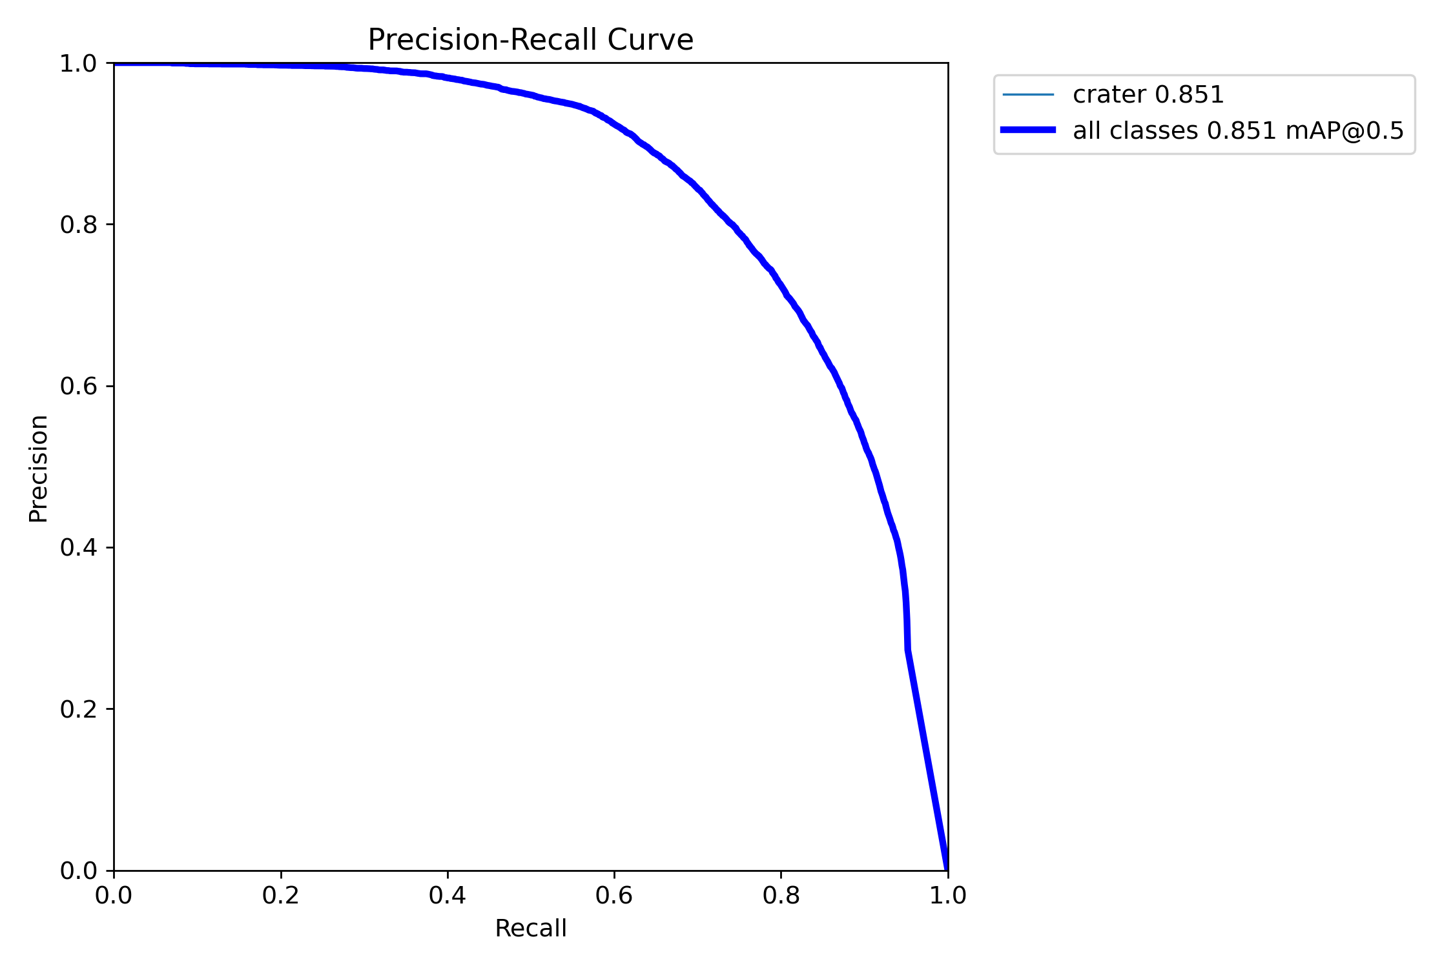
Equipment and Data Sources
Equipment Specifications
Operating System: Windows 11
Processor: AMD Ryzen 9 9900X
Graphics Card: NVIDIA RTX 4090
Dataset Source
The dataset used for this research is the "Optical-DEM Paired Lunar Crater Detection (ODPLCD) Dataset", released by the National Space Science Data Center on October 30, 2022. It consists of 2784 pairs of lunar crater images, including 1781 for training, 446 for validation, and 557 for testing. The optical images were captured by the Wide-Angle Camera (WAC) on the Lunar Reconnaissance Orbiter (LRO), and the DEM images were obtained from the Lunar Orbiter Laser Altimeter (LOLA) on the LRO and Kaguya satellites. The dataset size is 729.22 MB.
Dataset Link:
https://doi.org/10.57760/sciencedb.o00009.00312
Project Code
The project code can be found at:
https://github.com/Leven66/yolo_crater.git

Resume
1. Resume
Name: GONGYIYUAN
Gender: Male
Email: 1034071827@qq.com

Acknowledgements
I would like to express my deepest gratitude to my supervisor, Ye Ben, for his constant guidance, invaluable advice, and unwavering support throughout my research. His expertise has been essential to the success of this project.
I am also very thankful to the faculty and staff at Macau University of Science and Technology for providing the resources and academic environment that enabled this work to come to fruition.
Finally, I wish to acknowledge the researchers whose work has paved the way for my own. Their contributions have been truly inspiring.
Thank you all for your support and encouragement.

